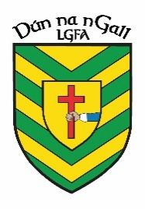
NEWS RELEASE
FOR IMMEDIATE RELEASE

Donegal LGFA
04/05/23

Donegal LGFA and Jacksons Hotel Announce Sponsorship of County U14 Team Jersey
Donegal and The Lagoon Bar & Restaurant Announce Sponsorship of County U14 Team Training Gear

Donegal LGFA
Donegal LGFA is delighted to announce a partnership with Jackson’s Hotel and The Lagoon in relation to sponsorship of our County U14 Panel.
It is great to have Jackson’s Hotel and The Lagoon onboard and we look forward to seeing these partnerships flourish in the future.

Jackson’s Hotel

Jackson’s is a part of the Gallen Hospitality Hotel Group and has been run by the Gallen family since 2017. It is a family run hotel in Ballybofey along the bank of the River Finn

www.jacksonshotel.ie

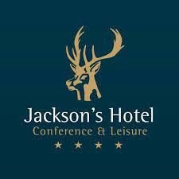

The Lagoon Bar & Restaurant

The Lagoon is a family run establishment. It provides luxurious accommodation and award-winning food for all while you relax on you explorations of stunning Donegal and the Wild Atlantic Way.

www.thelagoon.ie

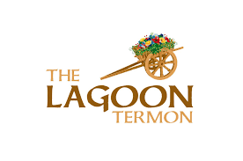
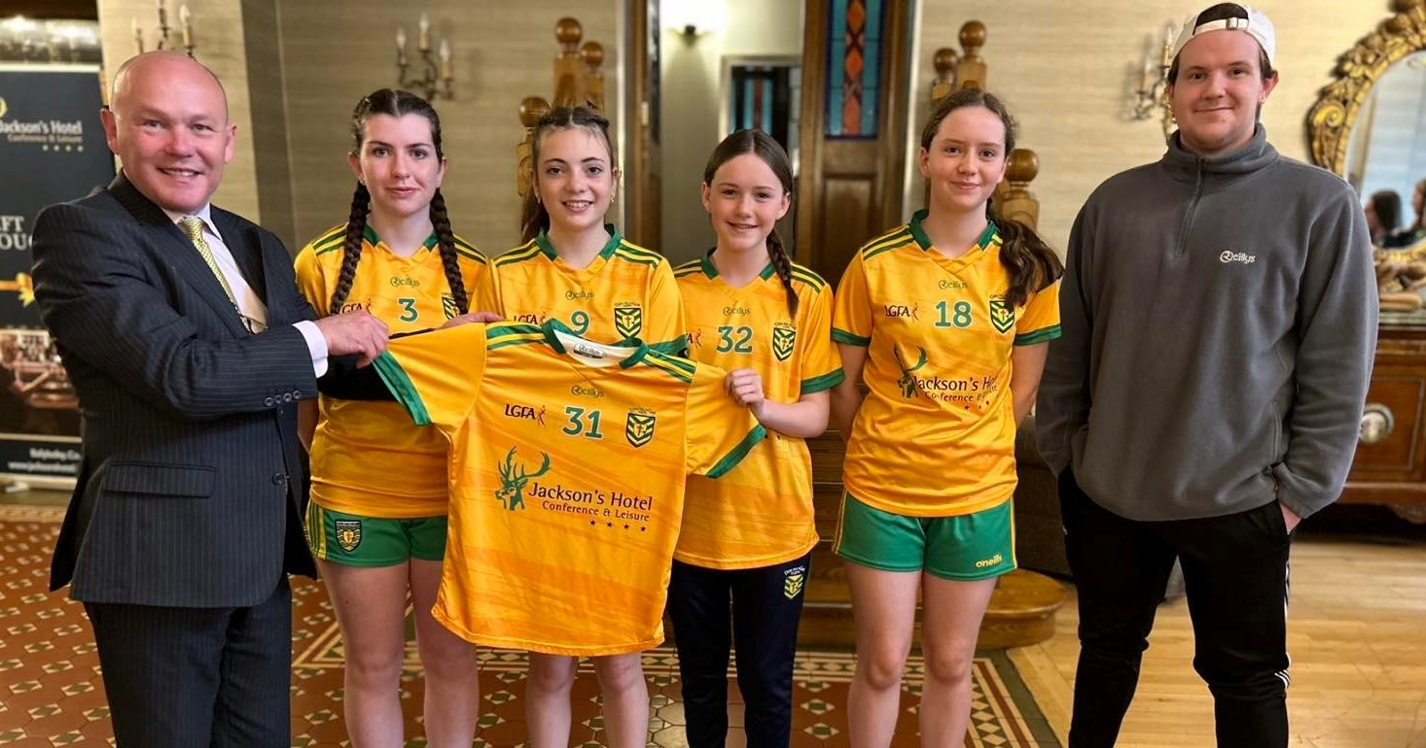

Jackson’s Hotel General Manager Philp Lee presenting Donegal U14 Captain Laura Boyle and Vice Captains; Aoibhinn McCann, Kate McClafferty and Laura Quinn with the new jerseys for 2023.
Also, pictured is Kieran Sheridan of O’Reilly Sports, official provider of Donegal LGFA Sportswear.

