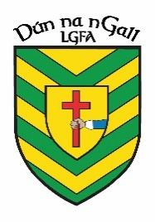
NEWS RELEASE
FOR IMMEDIATE RELEASE
Donegal LGFA
04/05/23

Donegal LGFA and Marley’s Coach Hire Announce Sponsorship of County U16 Team Jersey
Donegal LGFA and Healthwise Pharmacy Announce Sponsorship of County U16 Team Training Gear

Donegal LGFA
Donegal LGFA is delighted to announce a partnership with Marley’s Coach Hire and Healthwise Pharmacy in relation to sponsorship of our County U16 Panel.
It is great to have Marley’s Coach Hire and Healthwise Pharmacy onboard and we look forward to seeing these partnerships flourish in the future.

Marley’s Coach Hire

Marley’s provides clean, comfortable and affordable travel. Several of their vehicles are wheelchair accessible and equipped with Wi-Fi, charging points, tables, and toilet facilities. With Marley’s you can expect a top-quality vehicle driven by one of their friendly experienced drivers.

www.marleys.ie

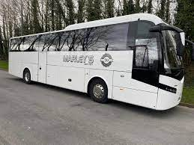

Healthwise Pharmacy

Healthwise Pharmacies are locally run community pharmacies that offer a wide range of products and services. “Caring for Your Community” is the mission statement of Healthwise Pharmacies.

www.healthwisepharmacies.ie

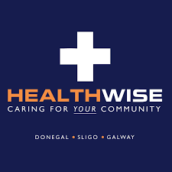
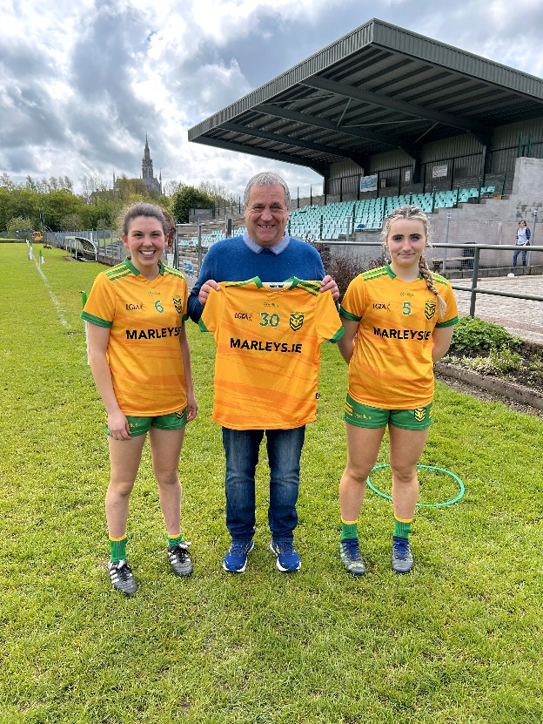
Francie Marley of Marley Coach Hire presenting Donegal U16 Captains Niamh Boner and Erin Leech with the new jerseys for 2023, by O’Reilly Sports; official provider of Donegal LGFA Sportswear.

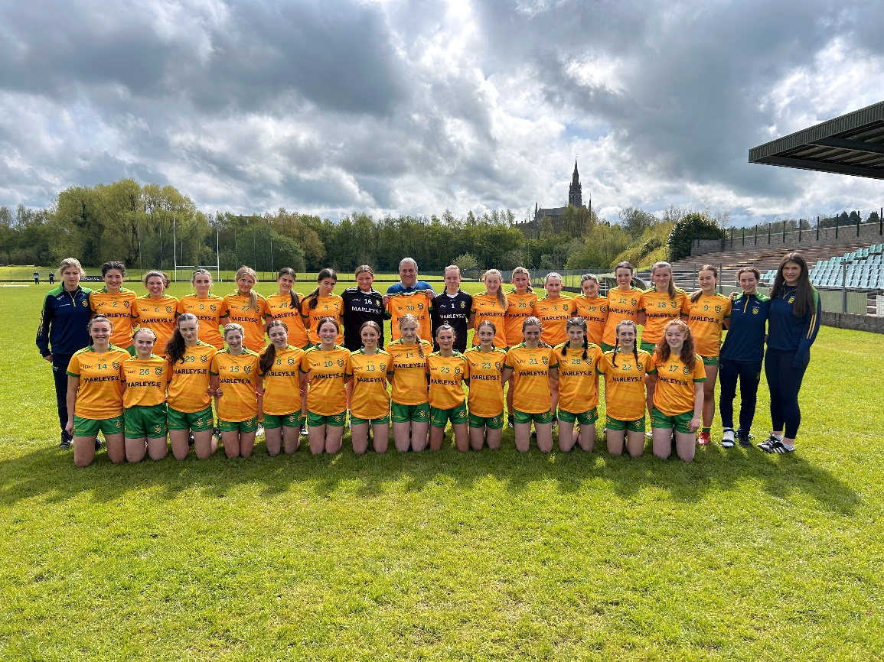
Francie Marley of Marley Coach Hire with the Donegal U16 Panel.

