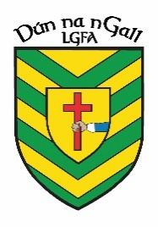
NEWS RELEASE

FOR IMMEDIATE RELEASE

Donegal LGFA
04/05/23

Donegal LGFA and the Credit Unions of Donegal Announce Sponsorship of Underage Club Leagues and Championships

Donegal LGFA
Donegal LGFA is delighted to announce a partnership with the Credit Unions of Donegal in relation to sponsorship of our Underage Club Leagues and Championships.
It is great to have the Credit Unions of Donegal onboard and we look forward to seeing this partnership flourish in the future.

Contact; pro.donegal@lgfa.ie

The Credit Unions of Donegal

Credit Unions offer members the chance to have control over their own finances by making their own savings work for them.

Every Credit Union is owned by its members.

Credit Unions only exist to serve its members, not to profit from their needs.

The money in Credit Unions always remains in the local community that the Credit Unions Serves.

Branches in Donegal:
Ballybofey & Stanorlar, Ballyshannon & Killybegs, Donegal Town, Gaoth Dobhair, Letterkenny, Lifford, Inishowen, Sheephaven, Swilly Mulroy, The Rosses
