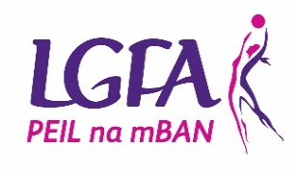
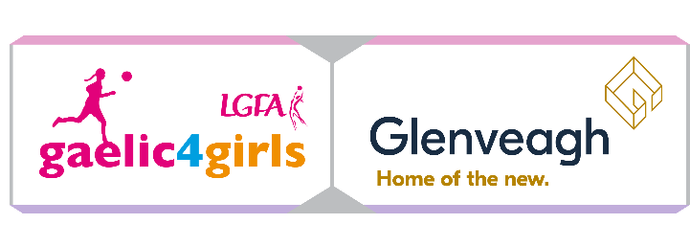
Connacht G4G Application form

To register your Club’s interest and apply for the 2024 Gaelic4Girls programme, please complete this application form and return to Connacht Development Officer Sarah Murphy- gdo.connacht@lgfa.ie by email by 15th November 2023.

Please Note – All sections must be completed or the application will not be accepted

Club Name: ______________________________________________
County: ______________________________________________
Club contact for this application: _____________________________________________
Phone: (Home): ___________ (Mobile): _____________________
Email: ________________________________
How long is your Ladies Football Club in existence? _______________________________
MEMBERSHIP FIGURES:
Age Group | Total number of registered members | Number of mentors currently involved with the team(s)
Under 8
Under 10
Under 12
Under 15
Under 16
Under 17
Under 18
Adult
Non Players
Gaelic4Mothers & Others

SCHOOL INFORMATION (fill in for both programmes)
Name of PRIMARY Schools in your area | Mixed/All Girls | Number of Girls aged 8 – 12 years

REASONS TO BE SELECTED:
Please give the top 3 reasons why your Club should be selected to host…
2024 Gaelic4Girls Programme

EVIDENCE
Please provide evidence to indicate that your Club has the sufficient resources to host the Gaelic4Girls Programme
 | Co-Ordinator | Coaches  (Min 3 per age group) | Facilities | Equipment
Gaelic4Girls programme

I confirm that:
- All information supplied in this application form is accurate
- I have read the G4G information sheet in full and will fully comply with all terms and conditions associated with the roll out of the programme(s)

Signed:__________________ Date: ____________________

Please note that any applications received after the closing date (15th November 2023) will not be considered for the Gaelic4Girls programme this year.

