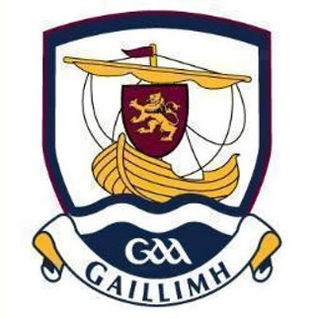
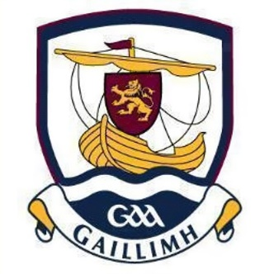
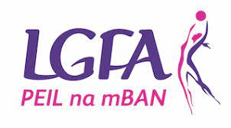

Galway LGFA are currently inviting applications for the position of

Senior Intercounty Manager

Minimum Requirements:
- Be a member of the LGFA & have good knowledge of how Ladies Football procedures & policies operate.
- Hold current Garda Vetting & Safeguarding certificates.
- Demonstrate at least 3 years of a successful track record in Club & or Inter County Management.
- Have an ability to demonstrate/organise a high standard of Coaching (At least a Level 1 Coaching Certificate is required).
- Have an understanding of & work within the Guidelines of the LGFA & the Code of Ethics & Good Practice for Young Players.

Applications are available on our website – www.galwaylgfa.ie and from County Secretary by emailing secretary.galway@lgfa.ie.

Completed applications must be returned via email to secretary.galway@lgfa.ie or by post to below address to reach the County Secretary no later than 5pm Friday 29th September 2023.

Geraldine Heverin,
Ballyedmond, Clonberne, Co. Galway H53E036

