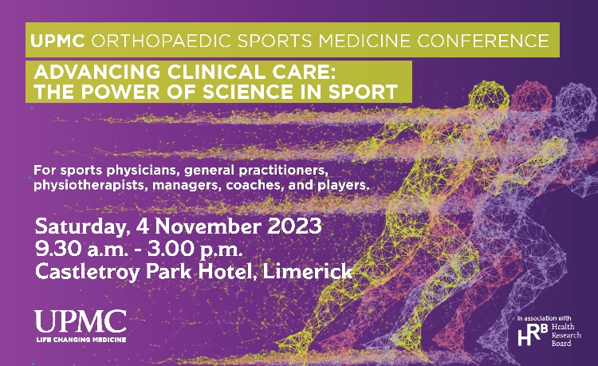

It is our great pleasure to invite you to attend “Advancing Clinical Care: The Power of Science in Sport” a Research Symposium hosted by UPMC Sports Medicine Clinic in association with the Health Research Board.

Saturday 4th November 2023, Castletroy Park Hotel Limerick
(09:00am – 3.00pm)

The aim of the meeting is to discuss advances in Orthopaedic and Sports Medicine research and how they translate to clinical practice.

The meeting will also give major opportunity for exchanges between various health care professionals, opening up discussion of current best practice and trends based on existing and ongoing research.

We would ask if you are keen to attend, please register at https://www.eventbrite.ie/e/upmc-orthopaedic-sports-medicine-conference-tickets-730390406367?aff=oddtdtcreator

Taking into account your expertise and the nature of your work, we hope to welcome you and your colleagues to the meeting.

Yours Sincerely,

Karen Mullins
Clinical Researcher at UPMC Sports Medicine

