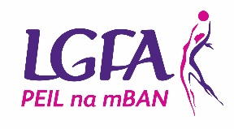
LGFA Interfirms Blitz
Saturday 5th October 2024
GAA National Games Development Centre, Blanchardstown, Dublin
Entry Form
Organisation: _________________________________ County: ______________________
Contact Name: _________________________________________________
Phone ______________________ (Work) ______________________ (Mobile)
Email: ____________________________________________________________
Mobile and email must be provided Please note your contact details will be held on file by the LGFA until completion of the Interfirms event for the purpose of forwarding relevant information to you relating to the event i.e. date, venue, timing, car parking, etc. Our Privacy notice is available at http://ladiesgaelic.ie/data-protection-and-gdpr/
Team Colours: (i) _________________________________________________________
(ii) _____________________________________________

Section You Want to Enter: Recreational Competitive
Please note each team must bring 2 sets of different coloured jerseys, or bibs, and 2 colour sets must be provided above.
Entry fee of €100 to be returned with this form not later than Friday 30th August 2024
Payment details (Payment will not be taken until your Place Confirmed in Competition)
Cheque:
Credit Card:
Card Number: ____________________________________________
Expiry Date: _____________ CVV: ___________

Signed: _________________________________ Date: _______________________________

Please complete & submit electronically to: Vinny Whelan - vincent.whelan@lgfa.ie 0871821668
Please ensure that you have fully completed form and you have entered the correct section. Submission of this form does not guarantee a place.

Cheques made payable to Ladies Gaelic Football Association and posted to: Vinny Whelan, LGFA, Croke Park, Dublin 3

